
CARBON REDUCTION PLAN GUIDANCE

Notes for Completion
Where an In-Scope Organisation has determined that the measure applies to the procurement, suppliers wishing to bid for that contract are required at the selection stage to submit a Carbon Reduction Plan which details their organisational carbon footprint and confirms their commitment to achieving Net Zero by 2050.
Carbon Reduction Plans are to be completed by the bidding supplier and must meet the reporting requirements set out in supporting guidance and include the supplier’s current carbon footprint and its commitment to reducing emissions to achieve Net Zero emissions by 2050.
The CRP should be specific to the bidding entity, or, provided certain criteria are met, may cover the bidding entity and its parent organisation. In order to ensure the CRP remains relevant, a Carbon Reduction Plan covering the bidding entity and its parent organisation is only permissible where the detailed requirements of the CRP are met in full, as set out in the Technical Standard and Guidance, and all of the following criteria are met:
- The bidding entity is wholly owned by the parent;
- The commitment to achieving net zero by 2050 for UK operations is set out in the CRP for the parent and is supported and adopted by the bidding entity, demonstrated by the inclusion in the CRP of a statement that this will apply to the bidding entity;
- The environmental measures set out are stated to be able to be applied by the bidding entity when performing the relevant contract; and
- The CRP is published on the bidding entity’s website.

Bidding entities must take steps to ensure they have their own CRP as soon as reasonably practicable and should note that the ability to rely on a parent organisation’s Carbon Reduction Plan may only be a temporary measure under this selection criterion.
The Carbon Reduction Plan should be updated regularly (at least annually) and published and clearly signposted on the supplier’s UK website. It should be approved by a director (or equivalent senior leadership) within the supplier’s organisation to demonstrate a clear commitment to emissions reduction at the highest level. Suppliers may wish to adopt the key objectives of the Carbon Reduction Plan within their strategic plans.
A template for the Carbon Reduction Plan is set out below. Please complete and publish your Carbon Reduction Plan in accordance with the reporting standard published alongside this PPN.

Carbon Reduction Plan Template
Supplier name: European Education Centre Limited
Publication date: 31 July 2024

Commitment to achieving Net Zero

European Education Centre Limited is committed to achieving Net Zero emissions by 2050.

Baseline Emissions Footprint
Baseline emissions are a record of the greenhouse gases that have been produced in the past and were produced prior to the introduction of any strategies to reduce emissions. Baseline emissions are the reference point against which emissions reduction can be measured.
Baseline Year: 2024
Additional Details relating to the Baseline Emissions calculations.
This report is the first report of CO2 emissions, and we will use it as the base line emission.
It is based on our financial accounting year of July to June 2024.
The baseline upon which these calculations were made consist of the followings:
- Scope 1 Onsite Generated emissions
- Scope 2: Emissions generated indirectly
- Scope 3: Fuel and energy related activities, Employee activities (commuting & working from home), Students activities and travel.
Baseline year emissions: 2023-2024
EMISSIONS | TOTAL (tCO₂e)
Scope 1 | 14.75 of tCO₂e through generating CO₂ by burning gas fuel
Scope 2 | 20.79 of tCO₂e through electricity consumption  14.75 of tCO₂e through Gas consumption
Scope 3  (Included Sources) | 21.34 of tCO₂ generated by students’ travel  1.15 of tCO₂ Generated by employees commuting and working from home
Total Emissions | 72.78 of tCO₂

Current Emissions Reporting
Reporting Year: 2024. These are the same as the base data
EMISSIONS | TOTAL (tCO₂e)
Scope 1 | 14.75 of tCO₂e through generating CO₂ by burning gas fuel
Scope 2 | 20.79 of tCO₂e through electricity consumption  14.75 of tCO₂e through Gas consumption
Scope 3  (Included Sources) | 21.34 of tCO₂ generated by students’ travel  1.15 of tCO₂ Generated by employees commuting and working from home
Total Emissions | 72.78 of tCO₂

Emissions reduction targets

In order to continue our progress to achieving Net Zero, we have adopted the following carbon reduction targets.

We project that carbon emissions will decrease over the next five years to 60 tCO₂e by 2029. This is a reduction of 16%
The progress of the carbon reduction will be compared with the projected targets and will be shown on the graph below

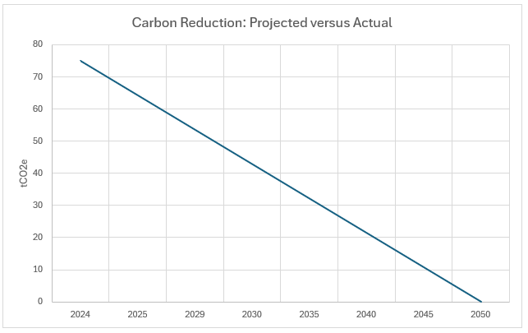

Carbon Reduction Projects
We have put in place several plans to implement in order to obtain the desired reduction and these are:
- Reduce the consumption of electricity by converting all lighting equipment to LED based Technology budgeted for the year 2024-2025
- Reduce the burning of gas by promoting the use of more efficient Heat pumps
- Improve recycling facilities on campus and initiatives to reduce and reuse waste.
- Raising students and staff environmental awareness and provide information to encourage energy efficiency
- Monitoring the level of CO₂ generated on campus by installing CO₂ sensors in all classrooms.
- Include the awareness through the involvement of students within their academic progression through activities and events
- Favouring contractors and delivery organisations that promote carbon reduction.

Completed Carbon Reduction Initiatives
The following environmental management measures and projects have been completed or implemented since the 2024 baseline.
As this is our baseline, we have not yet completed either partially or in full these projects However we have started working on a number of them especially collecting data from our activities in order to have a better understanding of our situation and assess our efficiency in reaching the set targets.
The carbon emission reduction achieved by these schemes equate to 0 tCO₂e, a 0% reduction against the 2024 baseline and the measures will be in effect when performing the contract.

In the future we hope to implement further measures such as:
- Development of a Travel Plan to encourage more sustainable modes of transport
- Investigate further improvements to energy efficiency such as building insulation.
- Working with organisations that provide solutions to reduce our carbon footprint

Declaration and Sign Off
This Carbon Reduction Plan has been completed in accordance with PPN 06/21 and associated guidance and reporting standard for Carbon Reduction Plans.
Emissions have been reported and recorded in accordance with the published reporting standard for Carbon Reduction Plans and the GHG Reporting Protocol corporate standard and uses the appropriate Government emission conversion factors for greenhouse gas company reporting.
Scope 1 and Scope 2 emissions have been reported in accordance with SECR requirements, and the required subset of Scope 3 emissions have been reported in accordance with the published reporting standard for Carbon Reduction Plans and the Corporate Value Chain (Scope 3) Standard.
This Carbon Reduction Plan has been reviewed and signed off by the board of directors (or equivalent management body).

Signed on behalf of the Supplier:


……………Caroline Gautier…………………………………………………….
Date: ………………2nd August 2024……….……….

Bidding supplier or ‘bidding entity’ means the organisation with whom the contracting authority will enter into a contract if it is successful.
Technical Standard can be found at: https://assets.publishing.service.gov.uk/government/uploads/system/uploads/attachment_data/file/991625/PPN_0621_Technical_standard_for_the_Completion_of_Carbon_Reduction_Plans__2_.pdf
Guidance can be found at: https://assets.publishing.service.gov.uk/government/uploads/system/uploads/attachment_data/file/991623/Guidance_on_adopting_and_applying_PPN_06_21___Selection_Criteria___3_.pdf
https://ghgprotocol.org/corporate-standard
https://www.gov.uk/government/collections/government-conversion-factors-for-company-reporting
https://ghgprotocol.org/standards/scope-3-standard

